

**SCHOOL OF ENGINEERING SCIENCE AND TECHNOLOGY**

**DIT 213 PROJECT PROPASAL**

**PROJECT TITLE:**

**WANT LIST**

**BY**

**KIBET TIMOTHY KIPCHIRCHIR**

**DIT/M/0252/01/19**

**A Report Submitted in Partial Fulfillment of the Requirement for the Award of a diploma in information technology of**

**Kabarak University**

**ABSTRACT**

This project is a web based shopping system. The project’s objective is to assist suppliers sell their goods and services to customers in need.

This project is an attempt to provide the advantages of online shopping to customers. It helps suppliers sell their goods and services anywhere through the internet. Thus the customer will get the service of online shopping and home delivery at his / her own comfort.

If suppliers are able to be in contact with a customer in need of goods and services through an online portal from anywhere, suppliers won’t be losing any more customers and thus will have high demands of goods and services being offered by suppliers in particular.

The title of the project is Want List system. It is a software which helps a customer (user) link up with a potential goods seller. Want List System is a 32/64 bit windows based operating system focused on the field of goods and services supply on high demand. In this software a person can either choose to become a supplier or customer

Whereby the two can be communicate to each other depending of each person’s role.

**DELCARATION**

I declare that this is my original work and to the best of my knowledge it has never been presented in this University or any other Institution of higher learning.

**Student name:** KIBET TIMOTHY KIPCHIRCHIR

**Registration No:** DIT/M/0252/01/19

**Sign:**

**Date:**

**DECLARATION BY SUPERVISOR**

This paper is the candidates’ original work and has been prepared with my guidance and submitted with my approval as the official university supervisor.

**Name:** MR. MUTAI JOSHUA

**Sign:**

**Date:**

**ACKNOWLEDGEMENT**

I take this occasion to thank God, almighty for blessing us with his grace and taking our endeavor to a successful culmination. I extend my sincere and heartfelt thanks to our esteemed guide, Mr. Mutai, for providing me with the right guidance and advice at the crucial junctures and for showing me the right way. I would like to thank the other faculty members also, at this occasion. Last but not the least, I would like to thank my friends for the support and encouragement they have given me during the course of our work.

ABSTRACTI

DECLARATIONII

DECLARATION BY SUPERVISORII

ACKNOWLEDGEMENTII

CHAPTER ONE: BACKGROUND INFROMATION1

1.1 INTRODUCTION1

1.1.1 PROJECT OBJECTIVE1

1.2 PROLEM STATEMENT2

1.3 PROJECT OVERVIEW3

1.4 JUSTIFICATION3

1.5 PROJECT SCOPE4

1.5.1 ASSUMPTIONS4

1.6 PROJECT RISK AND MITIGATION5

CHAPTER TWO: LITERATURE REVIEW6

2.1 INTRODUCTION6

2.2 SYSTEM ANALYSIS6

2.3 EXISTING SYSTEMS7

2.4 PROPOSED SYSTEM8

CHAPTER THREE: METHODOLOGY9

3.1 INTRODUCTION9

3.2 RESEARCH METHODOLOGY9

3.3 DATA COLLECTION9

3.4 SYSTEM DEVELOPEMTN10

3.4.1 ANALYSIS PHASE10

3.4.2 DESIGN PHASE10

3.5 CONTEXT DIAGRAM11

3.6 DATA FLOW DIAGRAM12

CHAPTER FOUR: SYSTEM ANALYSIS AND DESIGN15

4.1 INTRODUCTION15

4.2 SYSTEM REQUIREMENTS15

4.2.1 SOFTWARE REQUIREMENTS15

4.2.2 HADWARE REQUIREMENTS15

4.3 FUNCTIONAL REQUIREMENTS16

4.3.1 CUSTOMER FUNCTIONS16

4.3.2 SUPPLIER FUNCTIONS25

CHAPTER FIVE: IMPLEMENTATION AND TESING38

5.1 INTRODUCTION38

5.2 CONSTRUCTION OF SYSTEM COMPONENTS38

5.2.1 DEVELOPMENT ENVIRONMENT38

5.2.2 PROGRAMING ENVIRONMENT39

5.3 TESING40

5.3.1 UNIT TESTING40

5.3.2 INTERGRATION TESTING40

5.3.3 SYSTEM TESTING40

5.4 SYSTEM INSTALLATION40

REFERENCES41

APPENDIX42

APPENDIX A: CHART42

APPENDIX B: BUDGET43

**CHAPTER ONE: BACKGROUND INFORMATION**

* 1. **INTRODUCTION**

This project is a web based shopping system. The project’s objective is to assist suppliers sell their goods and services to customers in need.

This Want List System project enables a customer to have an electronic follow up of their requested goods and responses from suppliers meeting the customer’s demands. In addition to that, this system also narrows down the supplier’s efforts of having to physically look for potential buyers by having an electronic generated list of customers in need of goods and services. This system maintains a brief history or requested goods and services. It also manages all the requests and responses from both the customer and the supplier. It shall also maintain a database of all the details from both the supplier and the customer, more so sending notifications to a customer after every response from a supplier based on the goods or services requested. It is a smart UI that reduces workloads for both parties involved (the customer and the supplier).

* + 1. **PROJECT OBJECTIVE:**

The objective of the project is to make a web based application to purchase items in from a registered supplier. In order to build such an application complete web support need to be provided. A complete and efficient web application which can provide the online shopping experience is the basic objective of the project.

* 1. **PROBLEM STATEMENT**

The need or enthusiasm of wanting to acquire a certain item or service comes with many constraints; such as at what price will I obtain the item or service, from may I obtain the item or service, how will I obtain the item or service and most importantly will I get the item or service in time.

Goods and services can be accessed or acquired based on one’s motives and needs. As soon as one develops a certain need or motive towards a certain item or service, one will most certainly look for easier ways of how to achieve their desires and ease their motives and needs.

Many customers fail to establish a sense of trust with some so called suppliers who want to steal customer’s hard earned cash. Everyone at some point will need or require a certain type of service and they will require that each goods or service received values their money’s worth for having to purchase the goods or service.

* 1. **PROJECT OVERVIEW**

The central concept of the application is to allow the customer to shop virtually using the Internet and allow customers to buy the items and access of services from a registered supplier. The information pertaining to the products are stores on an RDBMS at the server side (store). The Server process the customers and the items are shipped to the address submitted by them. The application was designed into two modules first is for the customers who wish to buy the particular goods or particular services who update the information pertaining to the particular goods and services they desire. Second is for the supplier who reaches to a customer when they possess the customers required goods or services. The end user of this product is the developer where he / she hosts the application on the web and maintains the database. The application which is deployed at the customer database, the details of the items and services they require forward from the database for the customer view based on the selection through the menu and the database of all the products are updated at the end of each transaction. Data entry into the application can be done through various screens designed for various levels of users. Once the authorized personnel feed the relevant data into the system, several reports could be generated as per the security.

* 1. **JUSTIFICATION**

This system is neither designed to particularly target a specific audience nor specific goods and services. This system is available to anyone faced with desires, needs or motives of wanting a particular good or service. This will help reduce the fear of both customers and suppliers regarding payment and goods or services accessibility. In addition to that, it will help both parties establish a sense of trust as the system developer will adhere to safety measures once a customer or supplier is unsatisfied.

* 1. **PROJECT SCOPE:**

If suppliers are able to be in contact with a customer in need of goods and services

Through an online portal from anywhere, suppliers won’t be losing any more customers and thus will have high demands of goods and services being offered by suppliers in particular.

* + 1. **ASSUMPTIONS**

During the process of building this system to meet the objectives stated above, the following are the critical assumptions that will be made:

* + - * There will be enough time to develop and test the system with realistic data.
      * Suppliers who were interviewed for requirements elicitation, have an accurate and reliable understanding of the cost and procedures of delivering goods and services.
  1. **PROJECT RISK AND MITIGATION**

Though digitalization is good, it has its own risks that need to be identified and addressed. Awareness of these risks can help to build mitigation measures into the project planning and management. Below are some examples of risks and how they can be mitigated:

Computer viruses; the system will be web based; this means that the system is subjected to numerous risks of unauthorized access which can occur through hacking, computer virus and user ignorance among others. To cab this, the system should be secured using passwords and also data encryption and firewalls to secure the data. Authorized individuals should also be made aware of the consequences of misuse arising from improper use of their privileges.

**CHAPTER TWO: LITERATURE REVIEW**

**2.1 INTRODUCTION**

Most functionality in modern vehicles, such as cars, is in one way or another controlled by computers. Mechanical systems are increasingly replaced by software residing in the vehicle management system. As these management systems grow larger and larger, they become increasingly more complex to develop and maintain. Hand in hand with the increasing amount of control functionality demanded comes the increasing amount of information, or data, that this system should help in helping maintain the vehicles.

**2.2 SYSTEM ANALYSIS**

System analysis is the process of gathering and interpreting facts, diagnosing problems and using the information to recommend improvements on the system. System analysis is a problem solving activity that requires intensive communication between the system users and system developers. System analysis or study is an important phase of any system development process. The system is viewed as a whole, the inputs are identified and the system is subjected to close study to identify the problem areas. The solutions are given as a proposal. The proposal is reviewed on user request and suitable changes are made. This loop ends as soon as the user is satisfied with the proposal.

**2.3 EXISTING SYSTEMS**

The current system for shopping is to visit the shop manually and from the available product choose the item customer want and buying the item by payment of the price of the item.

* It is less user-friendly.
* Customer must go to shop and select products.
* It is difficult to identify the required product.
* Description of the product is limited.
* It is a time consuming process.
* Not in reach of distant user.

I have visited a couple of online goods and services management systems, and most of them do not allow their customers to express themselves on the goods and services they require. Most of them limit their customers to a categorized particular type of goods and services. More so most of them just inform the customer to pay up, and provide a customer with the gods or services accessibility date with no means of contacting the supplier. This leaves both the customer and supplier a great of sense of fear such as will both parties be satisfied with the exchange of goods and services.

This poses a threat to the industry and hence when the exchange of goods and services do not occur as planned both parties end up drowning in frustrations.

**2.4 PROPOSED SYSTEM**

In the proposed system customer’s need not go to the shop for buying the products. He / she can order the product he wish to buy through the web based application. Immediately on submission of required goods and services, all registered suppliers will be alerted of the customer’s request. Thus the supplier able to provide to the required items or services will submit a response. Hence the customer will choose from which available suppliers to purchase the product form.

**CHAPTER THREE: METHODOLOGY**

**3.1 INTRODUCTION**

This chapter will describe the different methodologies that will be used to conduct research and system development.

It is important to carefully choose the target group for any research activity in order to collect relevant and good quality data. The population targeted is not limited to one person customer needs and motives but also well-developed companies in need.

**3.2 RESEARCH METHODOLOGY**

Research is an essential and powerful tool in leading man towards progress. Without systematic research there would have been very little progress. The purpose of research is to discover answers to questions through the application of scientific procedure.

Interviews was the methodology of choice because they help you explain, better understand, and explore my subject opinions, behavior and experiences, this single unit of study allows for an in depth study of the problems facing the garage industry and this makes it easy to study and collect data that is pertinent to the system analysis and development process.

**3.3 DATA COLLECTION**

This describes the techniques that are adopted by the researcher for the collection of data. The primary technique used for data collection was interviewing my neighbors who have recently carried out online shopping. Observation of the current system and its processes was also used to gather additional data.

**3.4 SYSTEM DEVELOPMENT**

Object oriented methodology was the methodology of choice to be used in the analysis, design and implementation of this system. The reason for choosing this methodology lies on how it works. Object oriented method focuses on the behavior to be achieved by the system and it works by combining data elements and processes that are related into an object, this enables thorough representation of complex relationships and interactions that occur within a system making it easier to conduct analysis and design processes. This method results in the creation of systems that are easily extensible and whose components are highly reusable.

The method has three main phases; the analysis phase, the design phase and the implementation and testing phase. These phases are explained below.

**3.4.1 ANALYSIS PHASE**

This phase deals with the development of models to represent the real world application of the system using objects. This model specifies the how the system will function and is independent of the details of how it will be implemented. The model will be developed around the requirements of the system. These requirements will be gathered by interviewing both customers and suppliers specifically in need of goods and services and, through observation of the process that go on during the exchange of goods and services between the two.

**3.4.2 DESIGN PHASE**

In this phase, the analysis model is refined to cater for the users of the system. The refined model makes it possible to implement the requirements outlined in the analysis model. The components that are typically modeled include; the user interface, the database and the core applicatio

**3.5 CONTEXT DIAGRAM**

The figure describes a context diagram displaying the two major modules, the supplier of goods and services and the customer in need of goods and services.

CUSTOMER

SUPPLIER

**3.6 DATA FLOW DIAGRAM**

A Data Flow Diagram (DFD) is a structured analysis and design tool that describes the flow of data and the processes the data throughout a system.

FIGURE 1 CUSTOMER REGISTRATION DATA FLOW DIAGRAM

Database

Verification

email

Registration

Customer

Customer Records

Customer homepage

FIGURE 2 SUPPLIER REGISTRATION DATA FLOW DIAGRAM

Database

Verification

email

Registration

Supplier

Supplier Records

Payment

Supplier Homepage

activation

Account

FIGURE 3 CUSTOMER REQUEST DATA FLOW DIAGRAM

Database

Customer records

login

Verify

Customer login

Goods and or services request

Requests records

Database

FIGURE 4 SUPPLIER’S RESPONSE DATA FLOW DIAGRAM

Database

Requests records

Database

Supplier records

login

Verify

Supplier login

Supplier’s response

Fetch

Customer’s requests

Response records

Database

FIGURE 5 CUSTOMER RESPONSE ACCESS DATA FLOW DIAGRAM

Database

Response records

Customer records

Database

login

Verify

Customer login

Available supplier response and details

Fetch

Supplier response

Contact Supplier for further negotiations

**CHAPTER FOUR: SYSTEM ANAYSIS AND DESIGN**

**4.1 INTRODUCTION**

System analysis is the process of gathering and interpreting facts, diagnosing problems and using the information to recommend improvements on the system. System analysis is a problem solving activity that requires intensive communication between the system users and system developers.

System analysis or study is an important phase of any system development process. The system is viewed as a whole, the inputs are identified and the system is subjected to close study to identify the problem areas. The solutions are given as a proposal. The proposal is reviewed on user request and suitable changes are made. This loop ends as soon as the user is satisfied with the proposal.

**4.2 SYSTEM REQUIREMENTS**

System requirement specifications is a very important process during the software development. From a vast and wide category of software and hardware specification the following is what I found more user friendly to work with towards development of this application.

* + 1. **SOFTWARE REQUIREMENTS:**
* Web browser with support for HTML5
* XAMMP
* Windows or Linux based operating system
* Text Editor- sublime text
  + 1. **HARDWARE REQUIREMENTS:**

Computer with at least:

* + - 2Gb RAM memory
    - 20Gb available Hard Disk space
    - Processor speed of 1.5GHz

**4.3 FUNCTIONAL REQUIREMENTS**

This section will describe each module of the want list and how it works

**4.3.1 CUSTOMER FUNCTIONS**

The main function of the customer is to submit all his / her requests of certain goods and or services. Below are the available customer modules.

1. REGISTRATION INTERFACE

It is at this part where a customer registers to the want list system using:

* His / her full names.
* Desired username.
* Email address.
* His / her mobile phone number.
* Password of his / her choice.

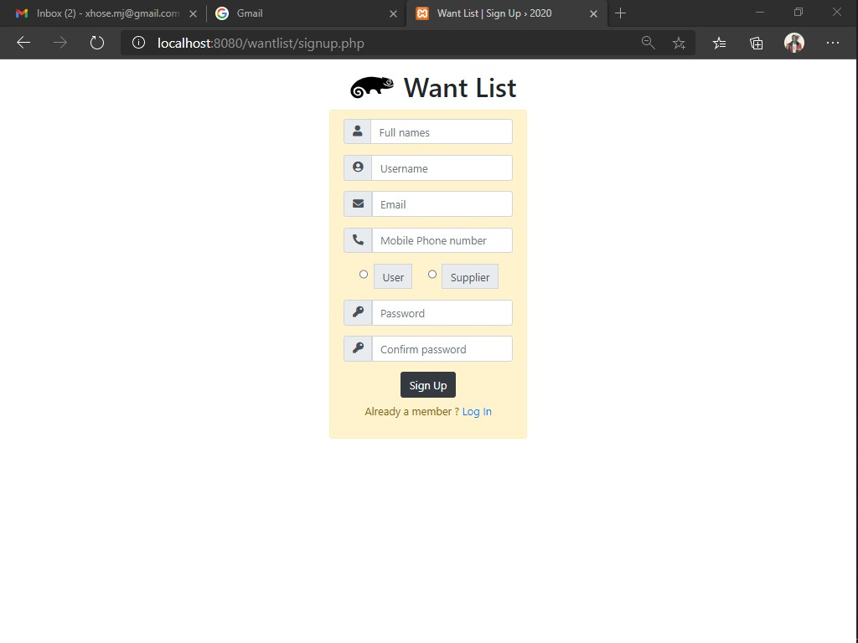

*Customer registration screen*

On signing up the admin will receive an email with a verification link to verify his / her account so as to be able to access want list services.

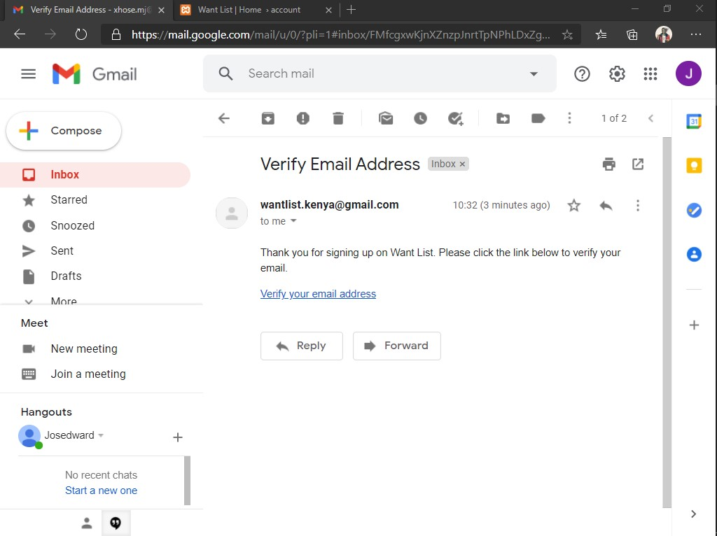

*Verification email*

1. CUSTOMER LOGIN INTERFACE

It is at this part where institution administrators are able to access their registered accounts. They will login into the tutelage system using:

* His / her username.
* Password of his / her choice.

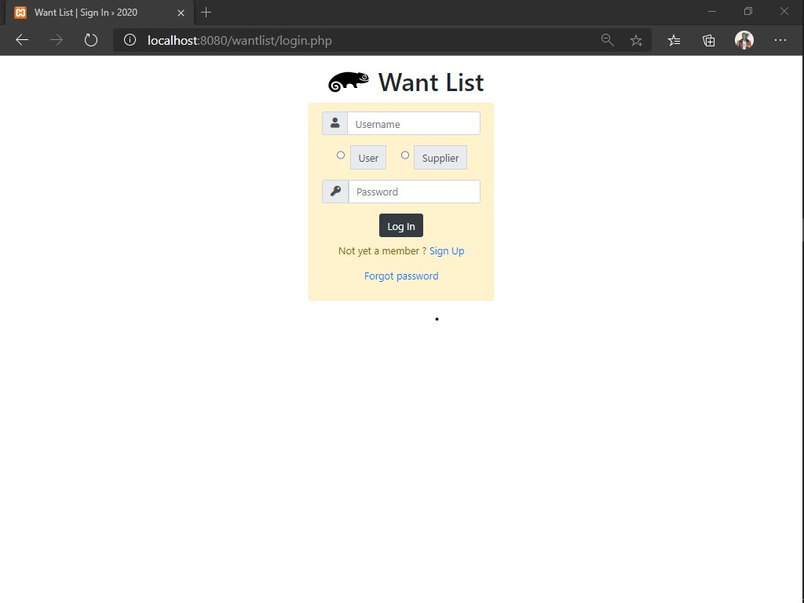*Customer login screen*

1. CUSTOMER ACCOUNT HOME PAGE INTERFACE

If the customer’s account is verified, he / she will be able to access want list services. It is at this page where the customer will be able to submit a his / her request of desired goods and or services.

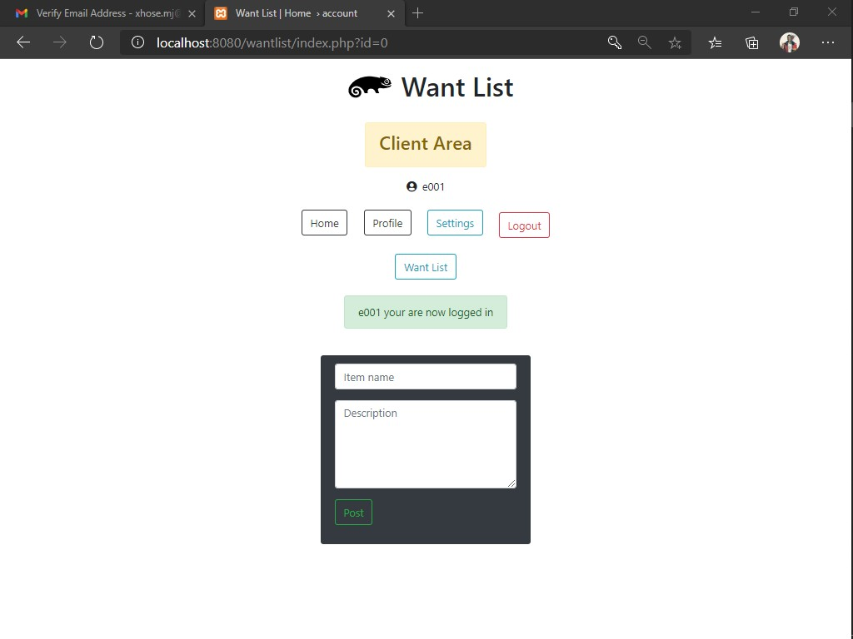

*Customer account home page screen*

VI. PROFILE INTERFACE

This section contains all registered customer details.

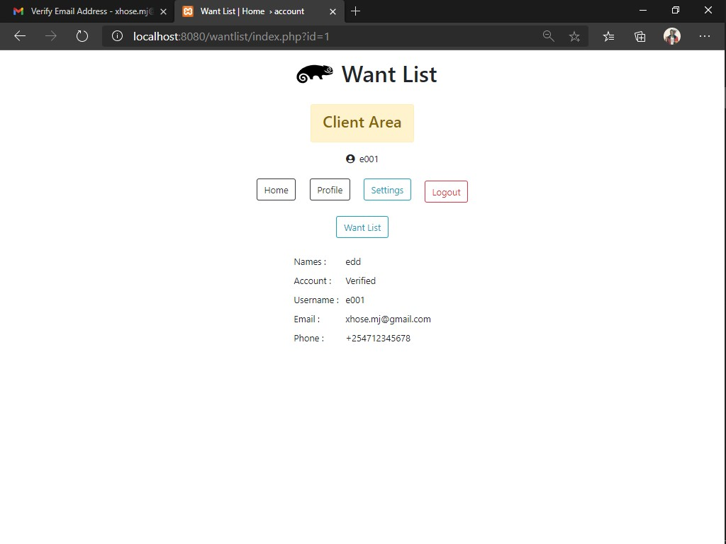

*Customer profile screen*

VII. CUSTOMER ACCOUNT SETTINGS INTERFACE

In this section the customer can be able to change his / her account password or delete his / her own account at will, more so delete his / her own account.

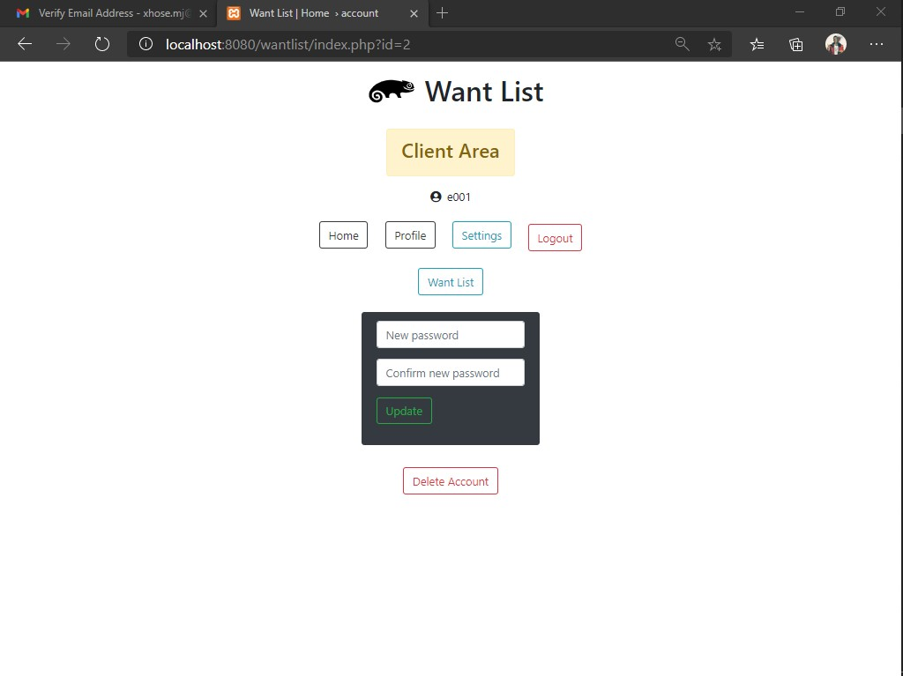

*Customer account settings screen*

VII. CUSTOMER RESPONSE INTERFACE

In this section the will be able to see all available response from supplier meeting the customers’ needs and demands.

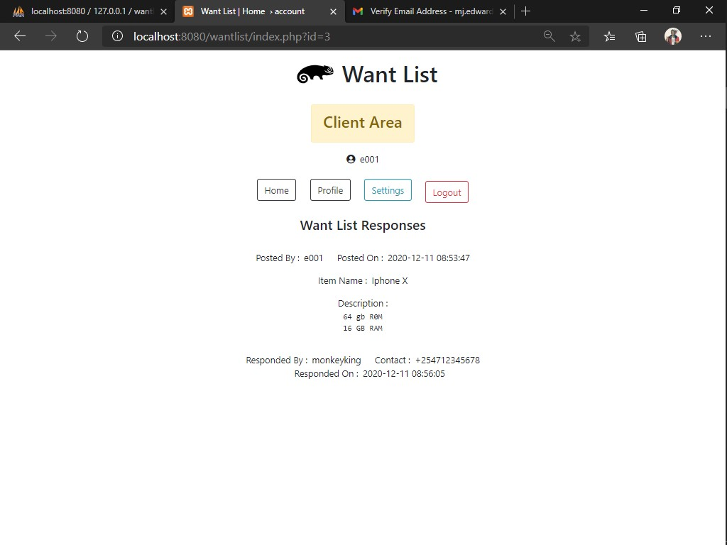

Nevertheless, the customer will not be able to see any response if none of the suppliers has responded to his / her request.

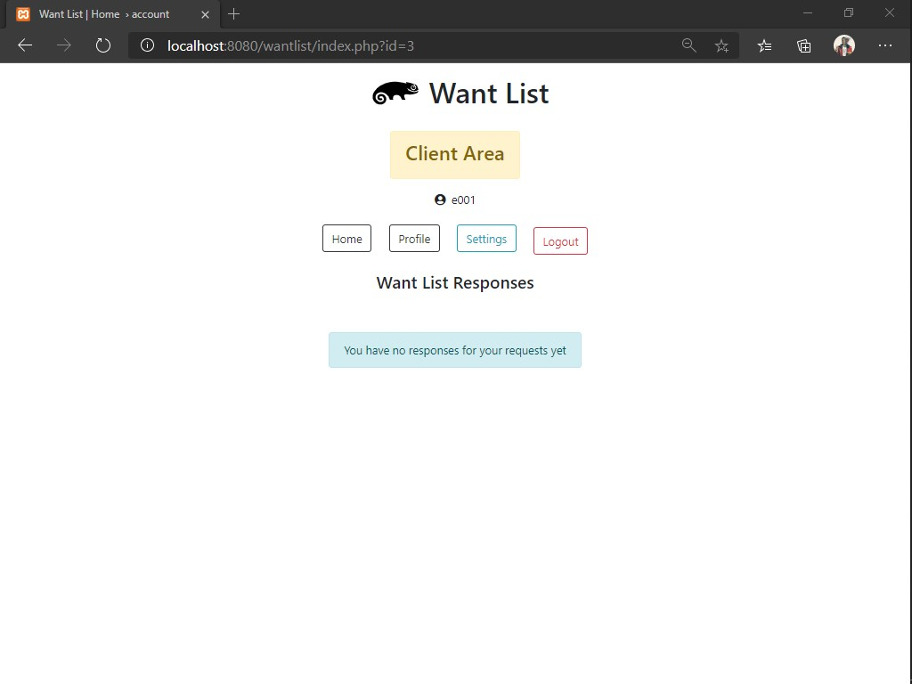

*Customer account response screen*

**4.3.2 SUPPLIER FUNCTIONS**

The main function of the supplier is to submit a response if he /she meets the customer’s needs and demands, if not then he / she is required to ignore the customer’s request. Below are the available customer modules.

1. SUPPLIER REGISTRATION INTERFACE

It is at this part where a customer registers to the want list system using:

* His / her full names.
* Desired username.
* Email address.
* His / her mobile phone number.
* Password of his / her choice.



*Supplier registration screen*

1. SUPPLIER LOGIN INTERFACE

It is at this part where a customer registers to the want list system using:

* His / her username.
* Password of his / her choice.



*Supplier login screen*

1. SUPPLIER ACCOUNT HOME PAGE INTERFACE

If the supplier has verified his / her account, he will be required to pay an account activation fee in order to activate his / her account and access the want list services.

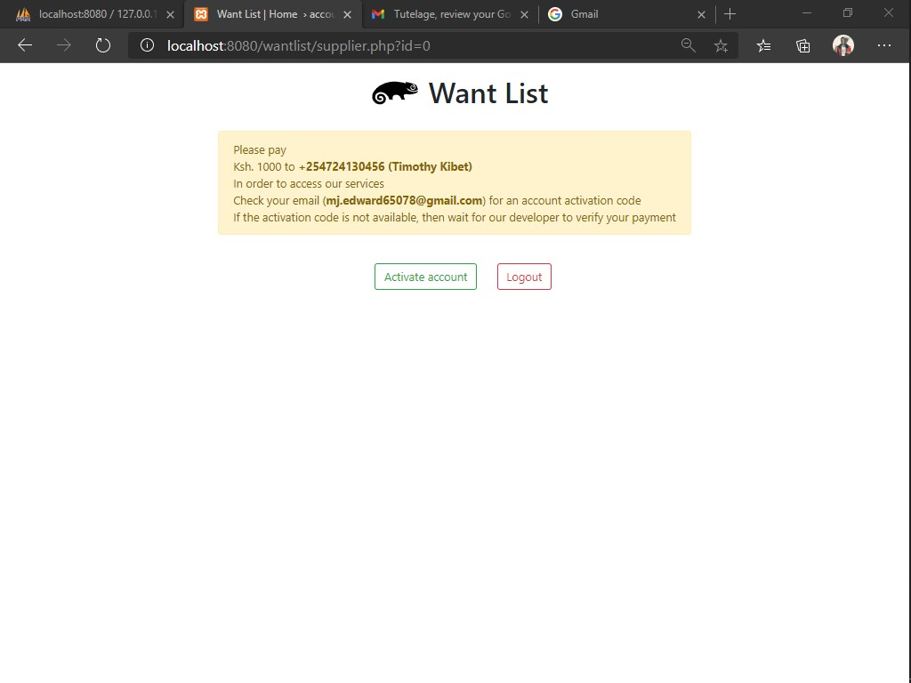

*Supplier account activation screen*

Once the supplier has successfully paid the activation fee, he / she is required to for our developer to confirm the payment. When the payment is confirmed the supplier an account activation code via his / her registered email address. If the activation code submitted by the supplier from the email, we sent is valid then the supplier will be able to access his / her account.

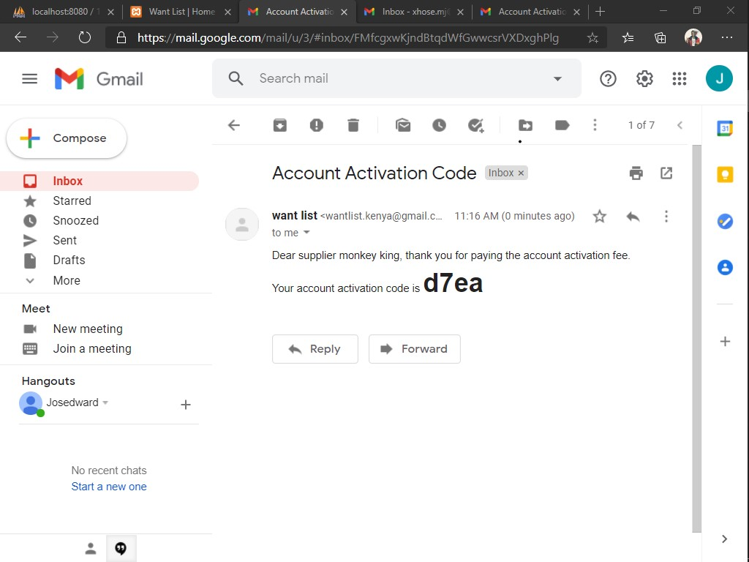

*Supplier account activation code email screen*

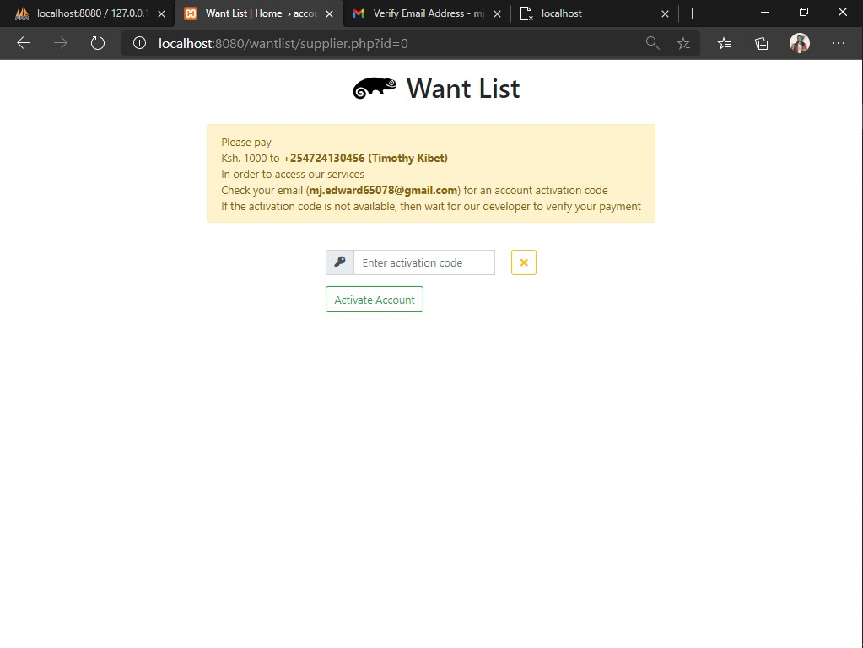*Supplier account activation screen*

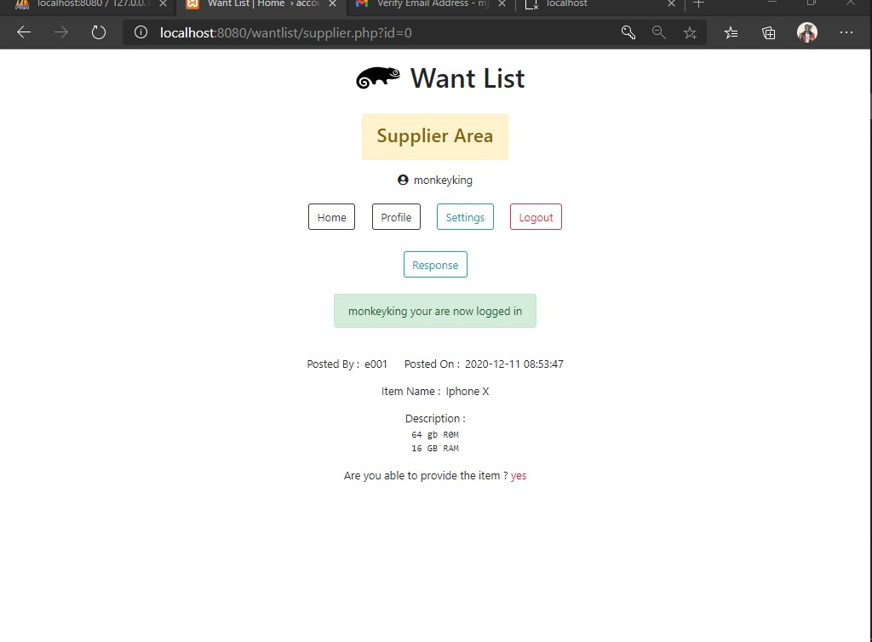

*Supplier account home page*

1. PROFILE INTERFACE

It is at this section where the registered supplier can view all the details concerning his / her registered account.

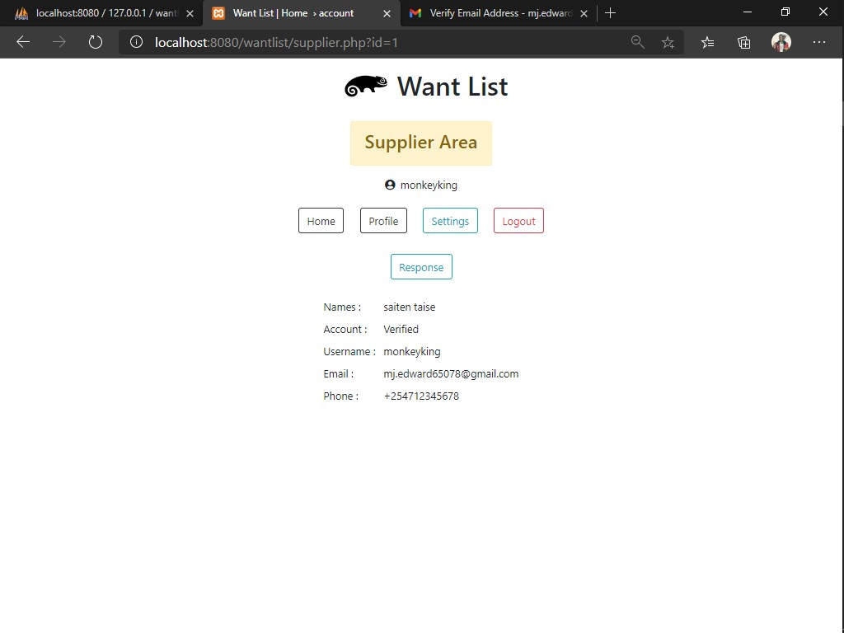

*Supplier account profile screen*

If the supplier has not verified his / her account, his / her account status will be unverified hence will be unable to access want list services.

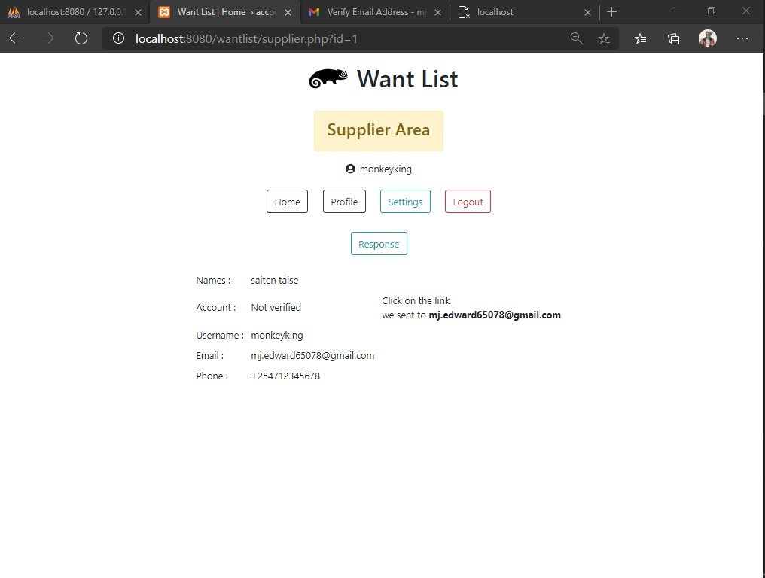

*Supplier account profile screen*

For the supplier to verify his / her account, he / she will be required to click on the account verification link sent to his / her registered email address.

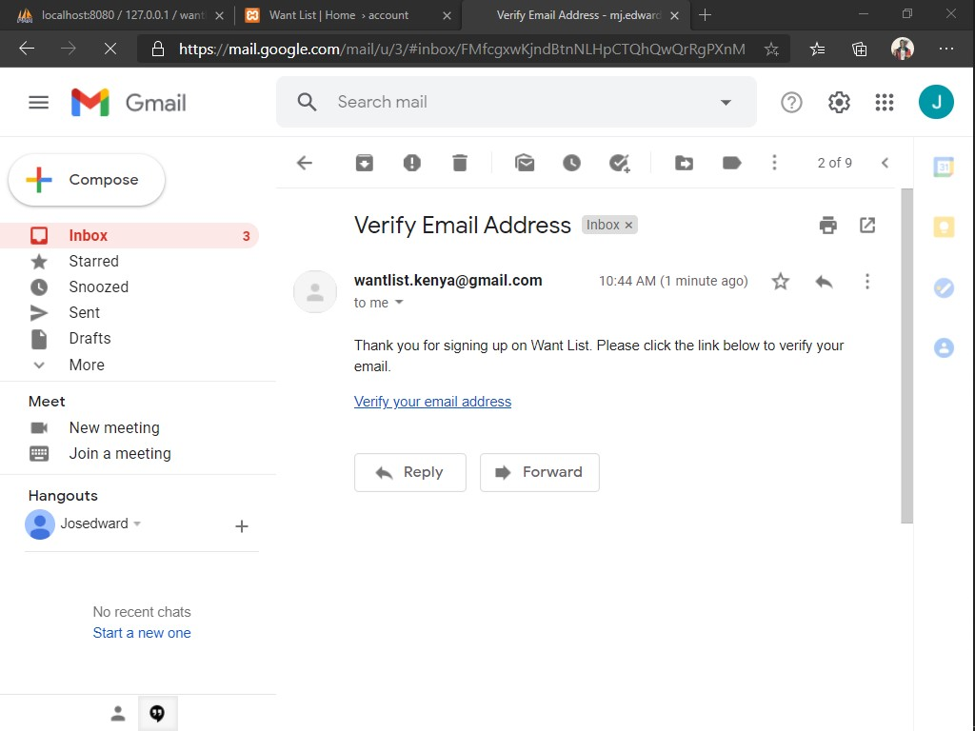

*Supplier account verification email screen*

1. SETTINGS INTERFACE

In this section the supplier is able to change his / her account’s password or delete his / her account permanently.

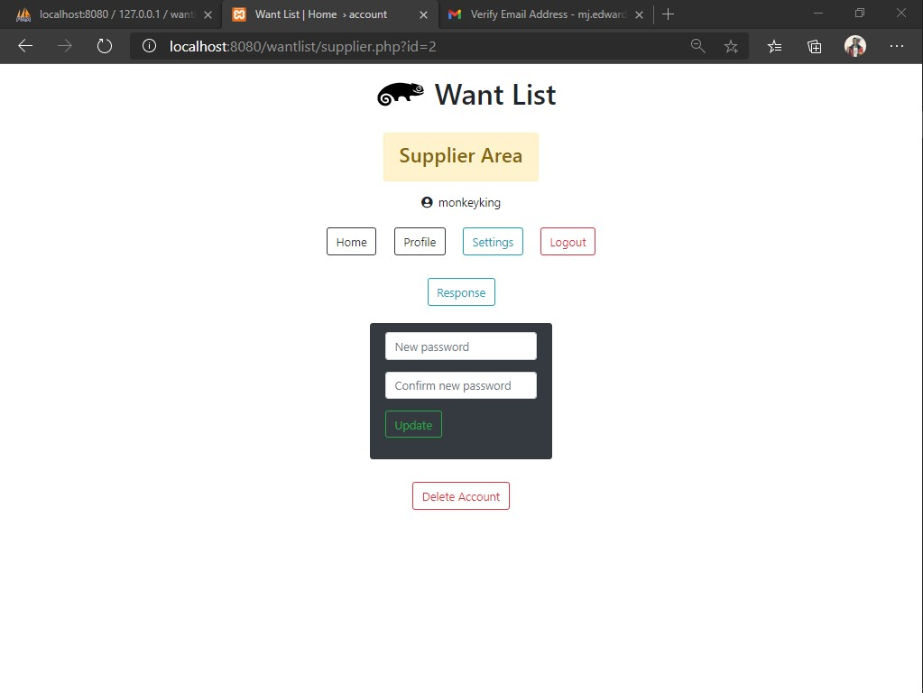

*Supplier account settings screen*

1. RESPONSE INTERFACE

In this section the supplier is able to submit a response based on customer’s requests.

Once a response is successfully sent, the supplier will receive an alert popup, informing him / her that his / her response has successfully been sent.

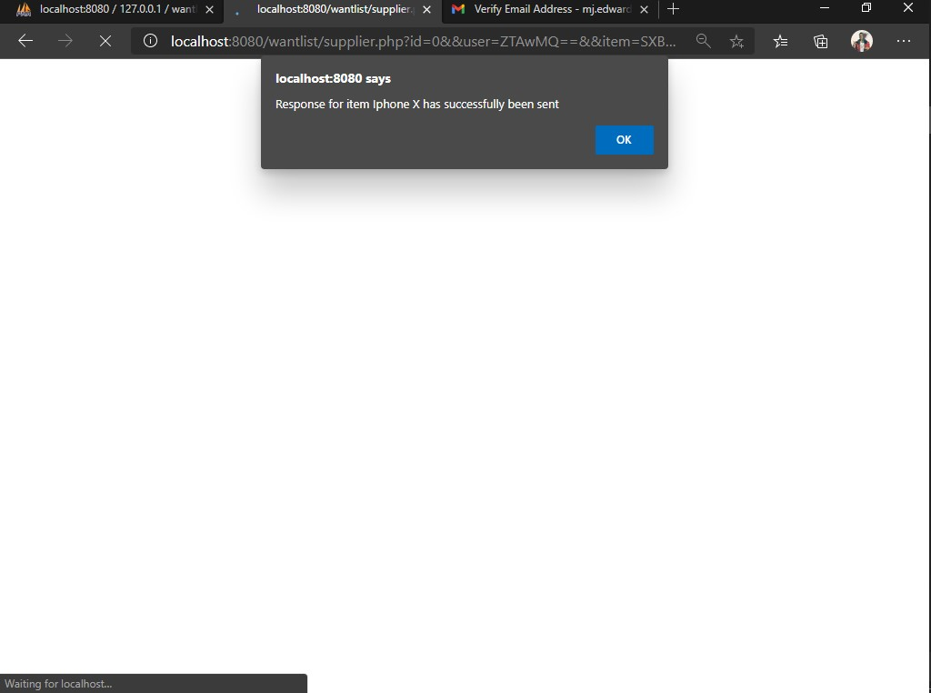

*Supplier account response alert screen*

The customer will then receive an email informing him / her that a certain supplier a has responded to his / her request and that he / she should contact the supplier, for further communication.

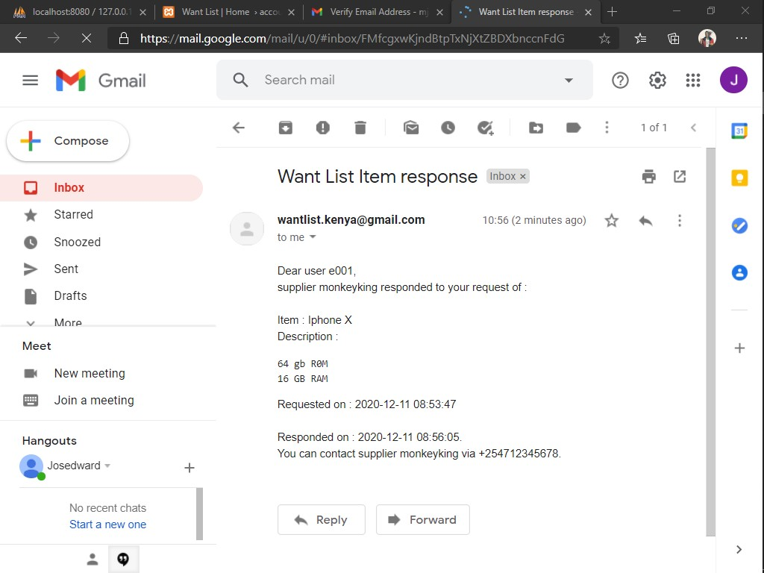

*Supplier response email to customer screen*

Finally, on successful submission of the response, the supplier will then be able to view his / her sent responses to various customers concerning their requests.

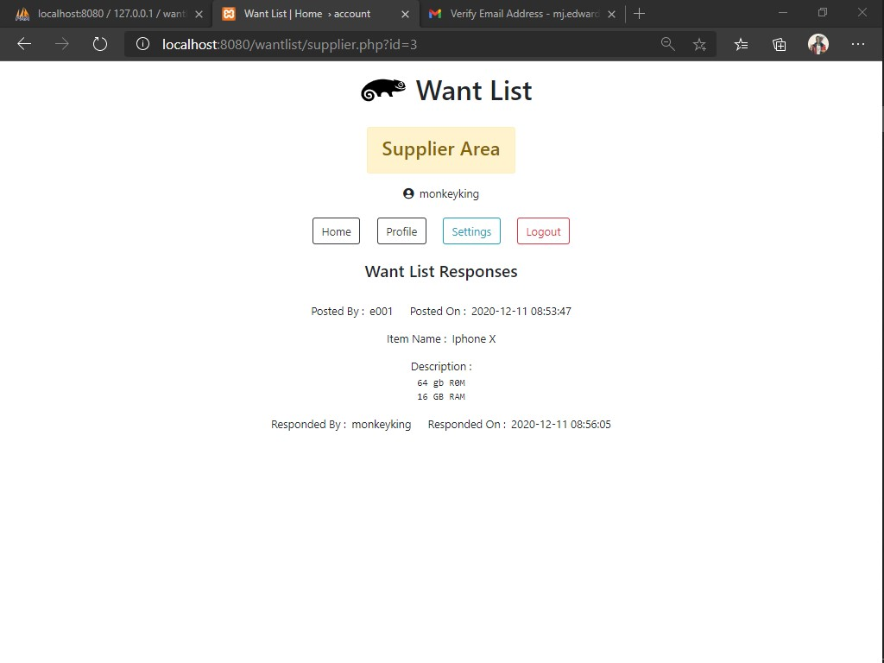

*Supplier account responses screen*

**CHAPTER 5: IMPLEMENTATION AND TESTING**

**5.1 INTRODUCTION**

This stage of system development deals with the construction of the system, how it is used and testing to make sure it meets all the requirements and functions correctly.

**5.2 Construction of System Components**

This refers to the programming process in development. System components are coded, following the design that was established in the design step.

**5.2.1 DEVELOPMENT ENVIRONMENT**

**HARDWARD**

Personal laptop computer with:

* + 1. 8Gb RAM memory.
    2. 250Gb available Hard Disk space.
    3. Processor with a 2.6GHz processing speed.

**SOFTWARE**

Google Chrome web browser

MySQL

Windows 64bit

Microsoft Visual Studio Code

JavaScript

PHP

Swift Mailer

**5.2.2 PROGRAMING ENVIRONMENT**

**BOOTSTRAP FRAMEWORK, HTML5 AND CSS3**

Bootstrap is a front-end framework used to create a fast, responsive and mobile first user interface to enhance the experience of accessing the site through mobile devices.

HTML5 is a language used in the programming of web-based interfaces for representation on browsers.

CSS3 is a scripting language used to style HTML elements to customize visual appearance.

**JAVASCRIPT**

JavaScript was used to create interactive effects of the system interface.

**PHP**

Used for server-side scripting to process data, query the database and provide responses to the clients.

**XAMMP**

XAMPP is an abbreviation for cross-platform, Apache, MySQL, PHP and Perl, and it allows you to build WordPress site offline, on a local web server on your computer.

In this case I used MySQL.

**SWIFT MAILER**

Swift Mailer is a component based mailing solution for PHP 7.

**5.3 Testing**

This is the use of test cases to test elements of the system modules before integrating with other modules and further testing the system as on whole.

**5.3.1 Unit Testing**

This involves individually testing modules to ensure that they are working as per design, producing expected outputs given a set of inputs.

*Test Case: adding a record*

|  |  |  |  |
| --- | --- | --- | --- |
| **Test Case ID** | **Scenario** | **Valid Data Inputs** | **Expected Results** |
| 1 | Successful add | Y | Store data in database |
| 1 | Invalid Inputs | N | Error Message |

**5.3.2 Integration Testing**

This involves testing all system modules together to ensure that they can interact as per the design, without error. This was done until all the system modules were tested, debugged and confirmed to be working correctly.

**5.3.3 System Testing**

This involves testing the entire system as one working unit to make sure it works well as per the design, without errors in logic or functionality. Both functional and nonfunctional requirements were tested.

**5.4 System Installation**

This site uses local server; you’ll need xampp installed in your pc to use the site.

**REFEENCES**

[User registration and email verification with PHP and MySQL database on localhost - YouTube](https://www.youtube.com/watch?v=8K4Wt37Itc4)

[CSS Tutorial (w3schools.com)](https://www.w3schools.com/css/default.asp)

[JavaScript Tutorial (w3schools.com)](https://www.w3schools.com/js/default.asp)

[PHP Tutorial (w3schools.com)](https://www.w3schools.com/php/default.asp)

[Bootstrap 4 Tutorial (w3schools.com)](https://www.w3schools.com/bootstrap4/default.asp)

[Font Awesome Intro (w3schools.com)](https://www.w3schools.com/icons/fontawesome_icons_intro.asp)

[JavaScript DOM Animate (w3schools.com)](https://www.w3schools.com/js/js_htmldom_animate.asp)

**APPENDIX**

**APPENDIX A: CHART**

|  |  |  |  |  |  |  |  |  |  |  |  |  |  |  |
| --- | --- | --- | --- | --- | --- | --- | --- | --- | --- | --- | --- | --- | --- | --- |
| YEAR | 2019 | | | | | | | | | | | | | |
| MONTH | May | | | | Jun | | | | | July | | | | |
| WEEKS | 1st | 2nd | 3rd | 4th | | 1st | 2nd | 3rd | 4th | | 1st | 2nd | 3rd | 4th |
| PROPOSAL |  |  |  |  | |  |  |  |  | |  |  |  |  |
| INTRODUCTION |  |  |  |  | |  |  |  |  | |  |  |  |  |
| REVIEWING INTRODUCTION |  |  |  |  | |  |  |  |  | |  |  |  |  |
| LITERATURE REVIEW |  |  |  |  | |  |  |  |  | |  |  |  |  |
| REVIEWING LITERATURE REVIEW |  |  |  |  | |  |  |  |  | |  |  |  |  |
| METHODOLOGY |  |  |  |  | |  |  |  |  | |  |  |  |  |
| IMPLEMENTATION AND TESING |  |  |  |  | |  |  |  |  | |  |  |  |  |
| FINAL REVIEWING OF PROPOSAL |  |  |  |  | |  |  |  |  | |  |  |  |  |

**APPENDIX B: BUDGET**

|  |  |  |  |  |  |  |
| --- | --- | --- | --- | --- | --- | --- |
| Items | Description | | Quantity | Cost | Total |  |
| Laptop | Intel Core i5 | | 1 | 30000 | 30000 |  |
| Safaricom Fiber | 5 mbps  Package | | 1 | 2999 | 2999 |  |
| Printing | Document printing | | 5 | 400 | 2000 |  |
| Total | Kes. 34999 |